Sour Cream Chicken
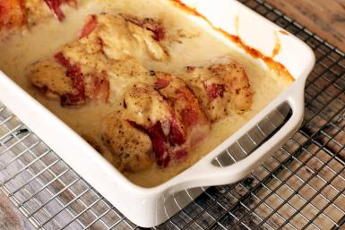
|
Servings: 4 large servings
Difficulty: Easy
Cook Time: Prep abt. 30 min, Cook 2hr. 15 min

Ingredients

4 Chicken breasts or 8-10 chicken tenderloins
1 can cream of (mushroom or chicken) soup
1 16 oz container of sour cream
1 pound of bacon

Cooking Directions
Wrap 1-2 strips of bacon around each piece of chicken and arrange in a baking dish. Bake, uncovered at 275 degrees for 1 ½ hours.
Mix sour cream and cream of soup in a mixing bowl. After cooking chicken for 1 ½ hours, pour the sour cream mixture on top and continue to cook for 45 more minutes.

